DW-RADIO live
Arts on the Air Artistic happenings from around Europe

Listen live

Art | 03.08.2009

Innovative German art project breathes life into vacant spaces

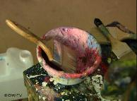

Boarded-up shop windows make cities look bleak and hopeless. A temporary art space in the German town of Karlsruhe is helping stop inner-city decay and bringing art directly to the people at the same time.

Until just a couple of months ago, this was an abandoned shop whose boarded-up windows were covered with graffiti. Now it's a glossy art space - albeit temporary - located smack-bang in the middle of Karlsruhe's bustling pedestrian zone.
Christine Geesing had the idea for a temporary art space after a pottery supplier closed up shop. His lease still ran for three months, and so he offered the store to artists to use for an exhibition.
Geesing was taken with the idea of using vacant shops and offices as a temporary space, but wanted to create something permanent - not just for a couple of months. As a result, together with seven like-minded artists and artisans, she created the Kunst Transit (or, "Art on the move") initiative.
"There are so many artists who would like to do something together," said Geesing. "And there are so many initiatives but a lot of them die because they are really suffering from lack of room."
Geesing is an artist herself. One of her works - showing plastic body parts from a doll embedded in a thick bed of white fake fur - is part of the current exhibition, entitled "In the middle of the moment."
Giving artists a chance
The idea behind Kunst Transit is to organize temporary exhibition spaces for artists and designers, both established and unknown. The initiative puts on a new group exhibition each month, offering a mix of objects with a range of prices - all on a volunteer basis.
According to Geesing, it was initially "quite hard" to convince people to provide the rooms rent-free to the initiative; although Kunst Transit pays water, gas and electricity, as well as the costs of renovating the space.
"Real estate managers couldn't see any reason why they should," she said. "And house owners - maybe they thought, 'Oh, artists, oh no. Maybe they'll just damage everything.'"
Geesing believes, however, it will be easier to find new premises when they have to leave their current space, which has been provided by the German drug store chain DM.
As the initiative becomes more established, people have started to realize what Kunst Transit can give back to the community, she said.
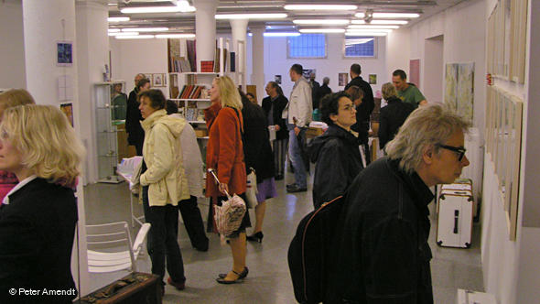Bildunterschrift: There's something in every price range
Contributing to the city
"(We are) putting a bit of contemporary art spirit into the town and giving this empty space for a moment something like significance," she said," something like a five minutes of fame for this room."
Karlsruhe painter Maike Tersch, who is taking part in this month's Kunst Transit exhibition, said it's "great" that vacant rooms are being used for art. For her, it's also important that the project gives artists a chance to exhibit outside of the professional galleries.
"At times, working with galleries really isn't easy," Tersch said. "In galleries, often the emphasis is on the art and the artist is forgotten. That can be problematic."
But Kunst Transit doesn't just benefit the artists but also the general public. The managing director of the Boesner art supplies company, Georg Schauer, who sponsors the project, said organizing an exhibition in a former store in the main shopping strip makes it easier for people to encounter art.
They "can enter without feeling embarrassed," he said. "They are maybe afraid of going to a gallery and here they can have the experience that for a lot of them is affordable and inspiring."
This month, Kunst Transit features a new section entitled "Small format." The section presents single art works from 20 artists. No work can be larger than 40 by 40 centimeters (8 inches by 8 inches), and more expensive than 200 euros ($285). The idea is to allow more artists to exhibit and to make original art affordable for the general public.
"We really hope to encourage people to buy art," Geesing said.
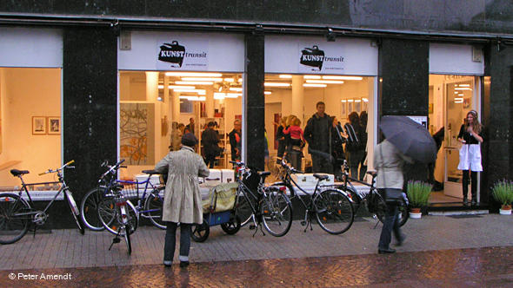Bildunterschrift: It's not always easy to find exhibition space, said Kunst Transit's founder
Author: Kate Hairsine
Editor: Kate Bowen

